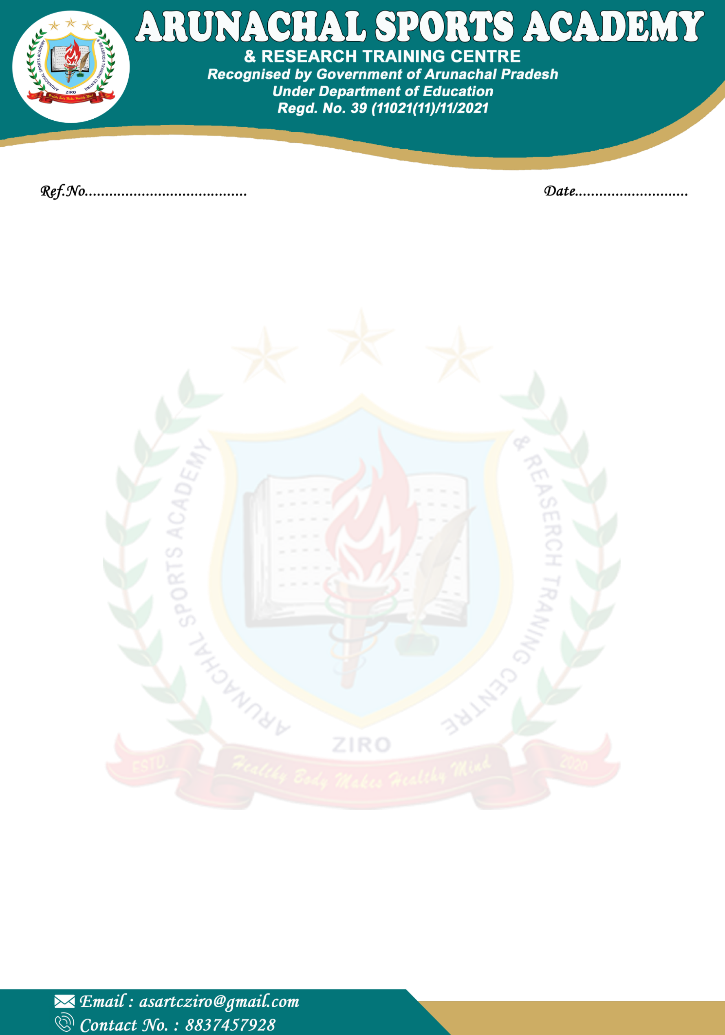

ASARTC/NOTCE EXAM. /2025-26/108
05/11/2025

NOTICE

This is to informed all the Parents/Guardians that the Final Terminal Examination will commence from 25th November 2025 onwards. Therefore, all concerned are to take of the given date. The Timetable/Routines will be circulated to the students at the earliest.
Note: Concerned parents who are yet to pay the instalments are hereby again requested to clear the dues.

(Visazokho Lhousa)
Principal
Arunachal Sports Academy
Ziro
Ph.: +91-6901145009

Copy to:
- All concerned Parents & Guardians for information
- Staff for information
- Notice board
- Office copy

